**Helping Hands**

Deliverable 3

4/18/2019

Anusha Malla

Briana Jenkins

Daniel Bae

Haythem Abdelkhalek

Trmnit Tesfatsion

Wonjin (James) Choi

IS 436 - Structured Systems Analysis and Design

Context DFD - Registration

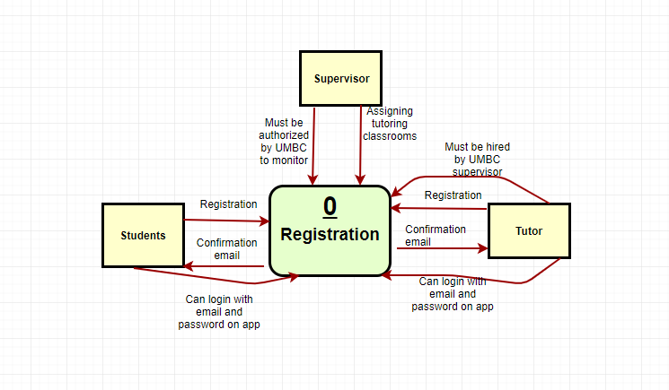

Level 0 DFD - Registration

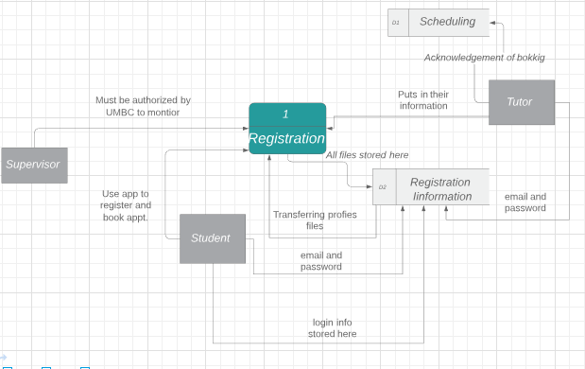

Text Definitions:

Context DFD: Registration

**Process**:

**Registration**: It is what we are working towards in order to better the old system. The system carries everything inside of it.

**Entity**:

* **1st Entity** = “Tutor”: Is the person that provides help to the students in the area that they need help in.
* **2nd Entity** = “Students”: They are the customer that goes to the tutors when needing help in a certain subject or area.
* **3rd Entity**  = “Supervisor”: Is the person that will oversee the whole business of what is going on between the student and tutors.

**Data Flow: (left to right)**

* **1st data flow:** going into Registration(process) from the supervisor is = “Must be authorized by UMBC to monitor” has to be authenticated in order to proceed with operations
* **2nd data flow:** going into the process from supervisor is = “ Assigning tutoring classrooms” so there will not be any confusion with booking.
* **3th data flow:** coming from the student entity to the registration process is = “can login with email and password on app” contains the authentication requirements for the student and tutor, so they can access the app.
* **4th data flow:** coming from student entity to the registration process is = “registration” which allows the student to sign up and get tutored.
* **5th data flow:** coming from the registration process to the student entity is = “confirmation email” contains and accepts the registration of the student in the database.
* **6th data flow:** coming from tutor entity to the registration process is = “registration” which allows the student to sign up and get tutored.
* **7th data flow:** coming from the registration process to the student entity is = “confirmation email” contains and accepts the registration of the student in the database.
* **8th data flow:** coming from tutor entity to the registration process is = “must be hired by UMBC supervisor” has to be apart of the system in order to start working and helping students.
* **9th data flow:** coming from the tutor entity to the registration process is = “can login with email and password on app” contains the authentication requirements for the student and tutor, so they can access the app.

Level 0 DFD: Registration

**Process:**

* **“Registration”** It is what we are working towards in order to better the old system. The system carries everything inside of it.

**Entity:**

* **1st Entity** = “Tutor”: Is the person that provides help to the students in the area that they need help in.
* **2nd Entity** = “Students”: They are the customer that goes to the tutors when needing help in a certain subject or area.
* **3rd Entity**  = “Supervisor”: Is the person that will oversee the whole business of what is going on between the student and tutors.

**DataStore:**

* **1st DataStore** = “D1 - Scheduling” stores all of the appointments that are formed by the tutors and students.
* **2nd Data Store** = “D2 - Registration Information” stores all of the profiles and personal information of the student and tutor.

**Data Flow: (left to right)**

* **1st Data flow**: coming from supervisor entity to process 1 = “Must be authorized by UMBC to monitor.” has to register so that they can oversee and keep track of what is going on.
* **2nd Data flow**: coming from process 1 to student entity = “Use app to register and book appt.” after the registration process the student can book an appt.
* **3rd Data flow**: coming from profiles to process 1 = “Transferring profile files” once the profiles from the tutor and student is created it is then brought through the registration process in order to process in the app.
* **4th Data flow**: coming from process 1 to registration information data store = “All files stored here” contains all of the processed registered profiles.
* **5th Data flow**: coming from tutor entity to process 1 = “puts in their information” allows them to register their information on the app.
* **6th Data flow**: coming from tutor entity to scheduling data store = “Acknowledgement of booking” allows the tutor appts scheduled to be stored in the app database.
* **7th Data flow**: coming from tutor entity to profiles= “email and password login” allows the tutor and student login info to be processed.
* **8th Data flow**: coming from profiles to registration information data store = “login info store here”stores all of the login requirements and info that is given and sent.
* **9th Data flow:** coming from student entity to D2 registration information = “ email and password” allows the tutor and student login info to be processed.

Context DFD - Forms

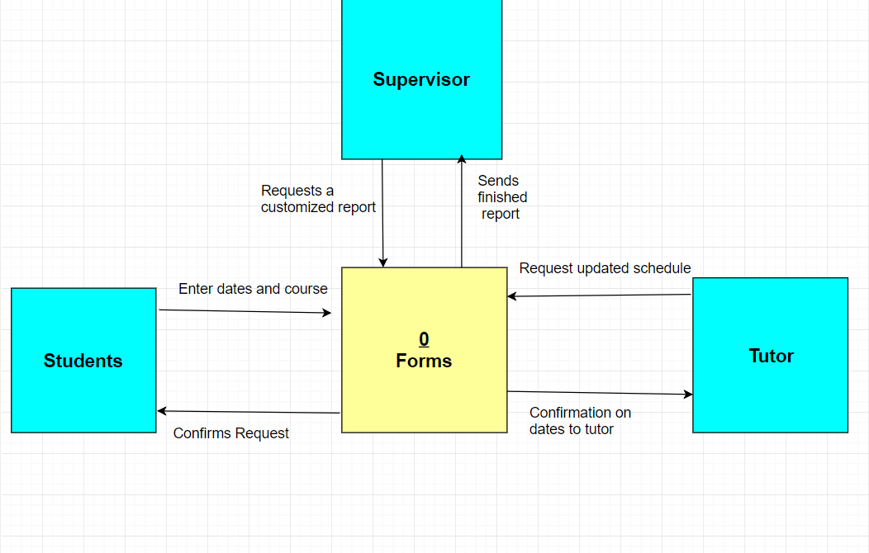

Level 0 DFD - FORMS

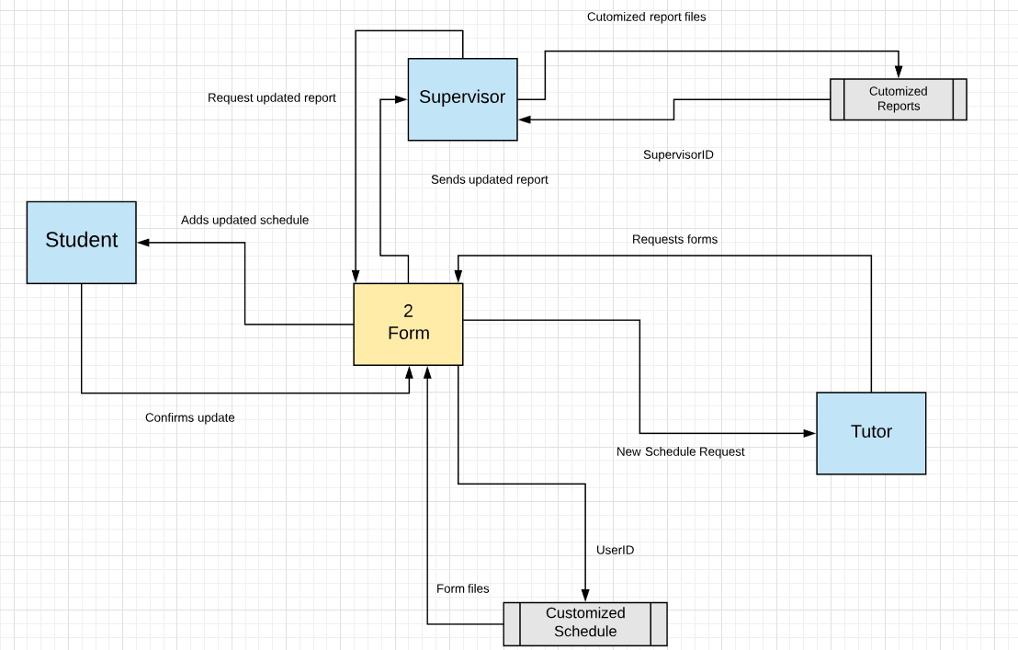

Text Definitions- Forms

Context DFD definitions:

**Process**:

Forms: The will have forms that can be customized to the students/tutors/supervisors needs.

**Entity**:

**1st Entity** = “Tutor”: Is the person that provides help to the students in the area that they need help in.

**2nd Entity** = “Students”: They are the customer that goes to the tutors when needing help in a certain subject or area.

**3rd Entity** = “Supervisor”: Is the person that will oversee the whole business of what is going on between the student and tutors.

**Data Flow:** (starting from left to the right)

**1st data flow:** "Enter dates and courses" the student will enter the appropriate date and class they want to be tutored for

**2nd data flow:** "Confirm request" the system will reply back to the student request by outputting available days and times for the courses they wanted to be tutored.

**3rd data flow:** "Requests a customized report" is when the supervisor wants to get the data from the system about the daily appointments

**4th data flow:** "sends finished report" is when the system responds from the supervisor request to get a daily or weekly report on appointments.

**5th data flow:** "Request updated schedule" is when the tutor wants to update the available dates he or she is able to teach.

**6th data flow:** " confirmation on dates to tutor " is when the tutor is given a response from the system on when to teach.

**Context Diagram: Updating Schedule**

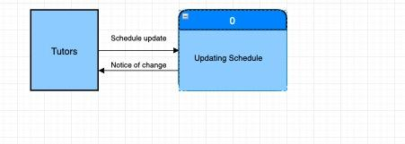

Level 0 DFD: Updating Schedule (Fragment)

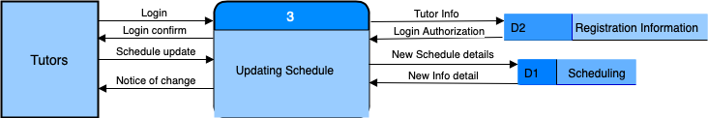

**Process:**

* **1st process** =“Updating Schedule” this allows the tutor to update their schedule if any change occurs to their availability throughout the semester.

**Entity:**

* **1st Entity** = “Tutor”: a person who works as a guide to student to better their academic achievement

**DataStore:**

* **1st DataStore** = “D1 - Scheduling” stores the updated schedule given by tutors and replaces their old schedule
* **2nd Data Store** = “D2 - Registration Information” this is where the tutors information is stored

**Data Flow:(**left to right)

* **1st Data flow**: coming from tutor entity to process 3 = “Login” the tutor have to login in order to update their schedule
* **2nd Data flow**: coming from process 3 to D2= “Tutor Info” after the tutor attempts to login, the login information is checked again the database information
* **3rd Data flow**: coming from D2 process 3= “Login Authorization” this authorized the login of the turot if the info matches what is stored in the D2 database.
* **4th Data flow**: coming from process 3 to tutor entity is = “Login Confirm” this lets the user to receive a message that says they are able to login to the system
* **5th Data flow**: coming tutor entity to process 3 is = “Scheduling update” tutor submits hew/his update schedule information
* **6th Data flow**: coming from process 3 to D1:scheduling is = “New Schedule Details” this allows the database to store the update schedule and replace old scheduling information
* **7th Data flow**: coming from D1:scheduling to process 3 = “New Info Detail” this sends a message of the updated schedule in the system
* **8th Data flow**: coming from process 3 to tutor entity is = “Notice of Change” this is a message displayed to the tutor about whether their schedule has been updated or not.

**Context DFD – Appointment**

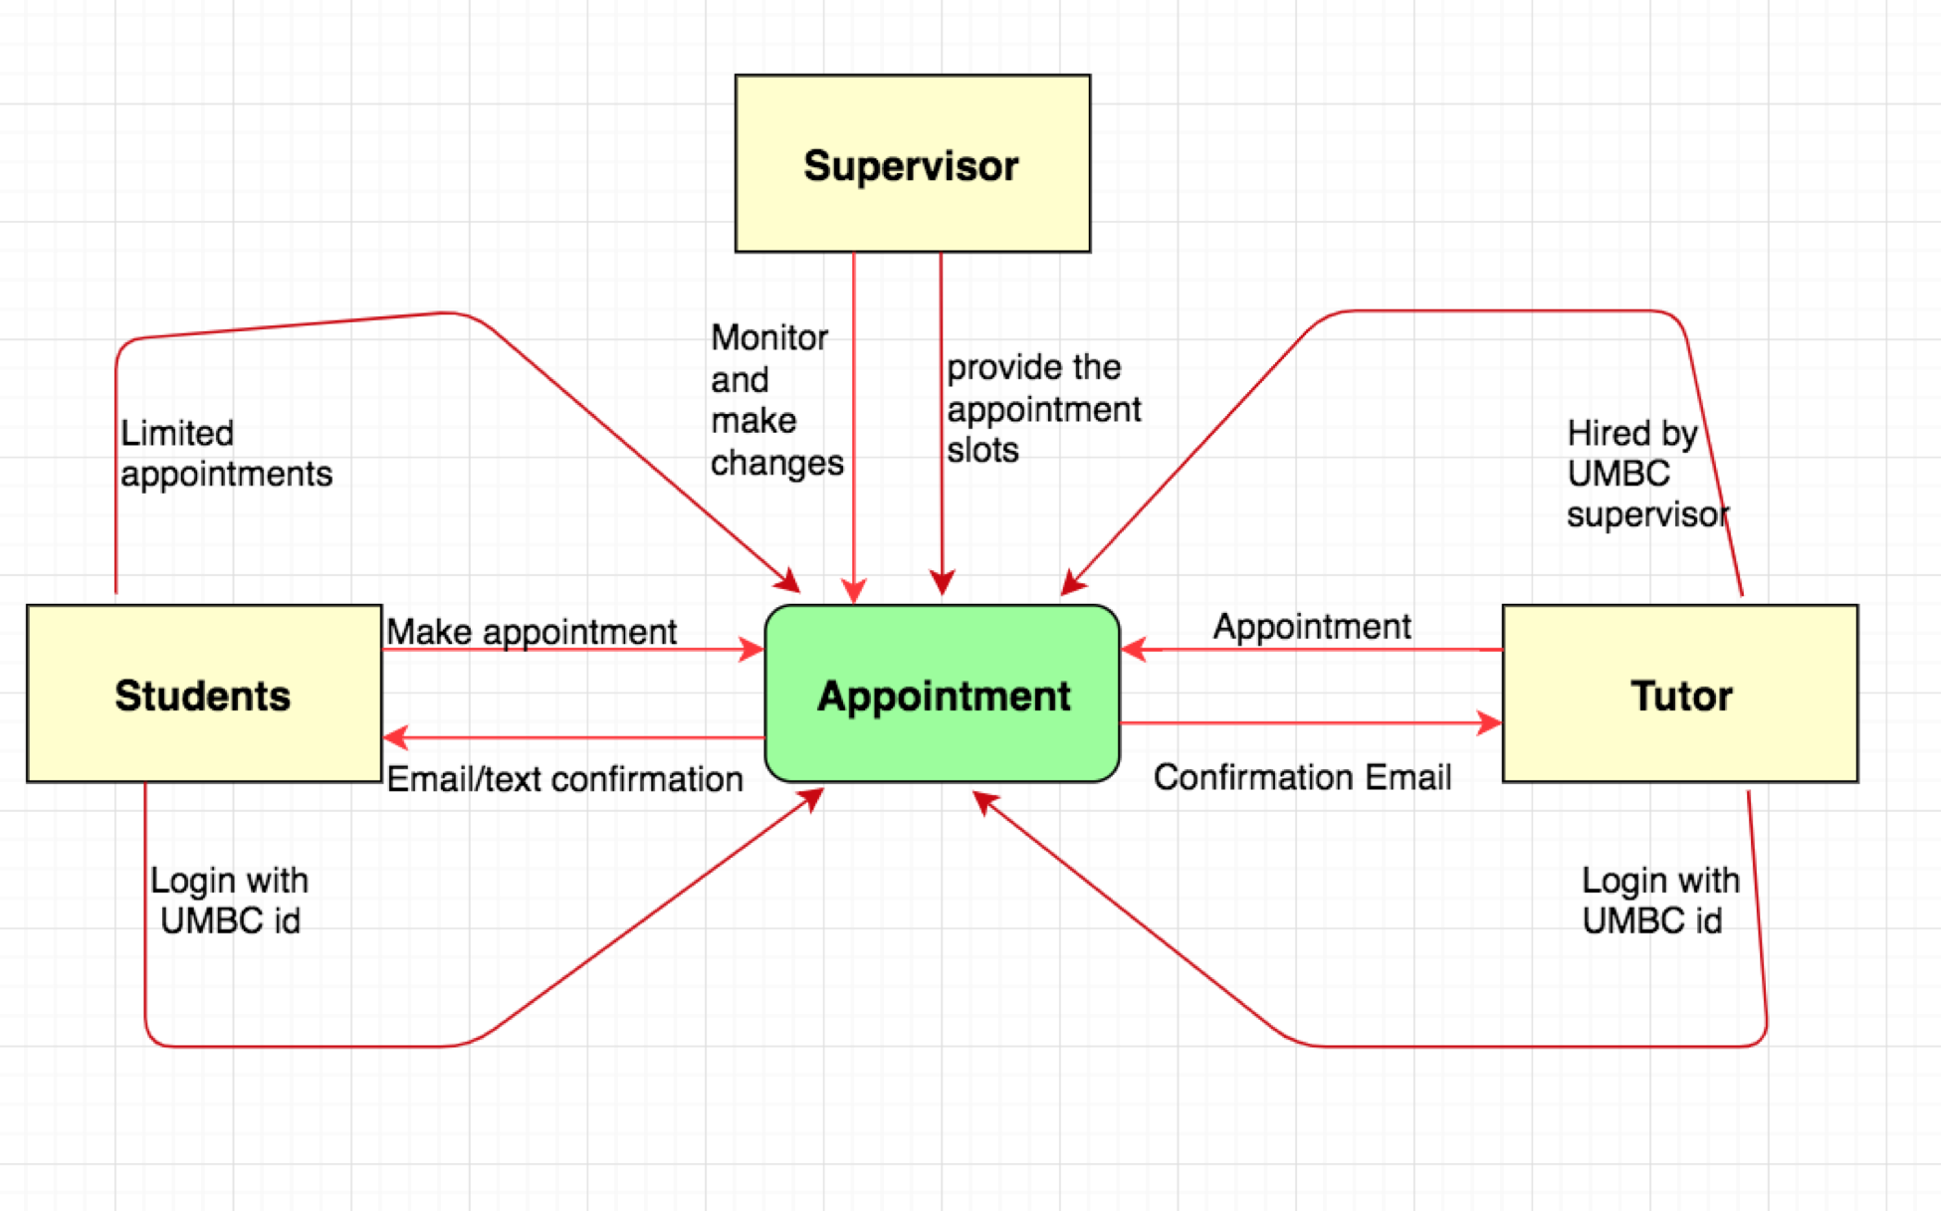

**Text Definitions:**

**Context DFD: Appointment**

**Process:**

**Appointment:** We are working to improve the older version of appointment to make it easier and flexible. The system carries everything inside of it.

**Entity:**

* **1st Entity** = “Tutor”: Is the person who provides the available slots for appointment.
* **2nd Entity** = “Students”: They are the customer who book an appointment with the tutors if needed.
* **3rd Entity** = “Supervisor”: Is the person that will oversee the whole business of what is going on between the student and tutors.

**Data Flow:**

* **1st data flo**w: going into Appointment from Supervisor is: Monitor and make changes on the appointment and the system.
* **2nd data flow**: going into the process from Supervisor is: to make the appointment slots available to the students and the tutors.
* **3rd data flow**: coming from tutor entity to Appointment is “Login with UMBC id” which will allow the tutors to log into the system with UMBC id only and get access to the tutor account.
* **4th data flow**: coming from tutor entity to Appointment process is “Appointment” which will allow the tutors to provide their available time for the tutoring appointment.
* **5th data flow**: coming from tutor entity to Appointment is “Confirmation” which will send text/email as a notification/ confirmation to the tutors once they are appointed for tutoring.
* **6th data flow**: coming from student entity to Appointment is “Login with UMBC id” which will allow the students to log in to the system
* **7th data flow**: coming from student entity to Appointment is “Confirmation” which will send email/text confirmation once the appointment is made and a notification prior to the appointment time.
* **8th data flow**: coming from student entity to Appointment is “Appointment” which will allow the students to book with the available tutors as needed.

**Level 0 DFD: Appointment**

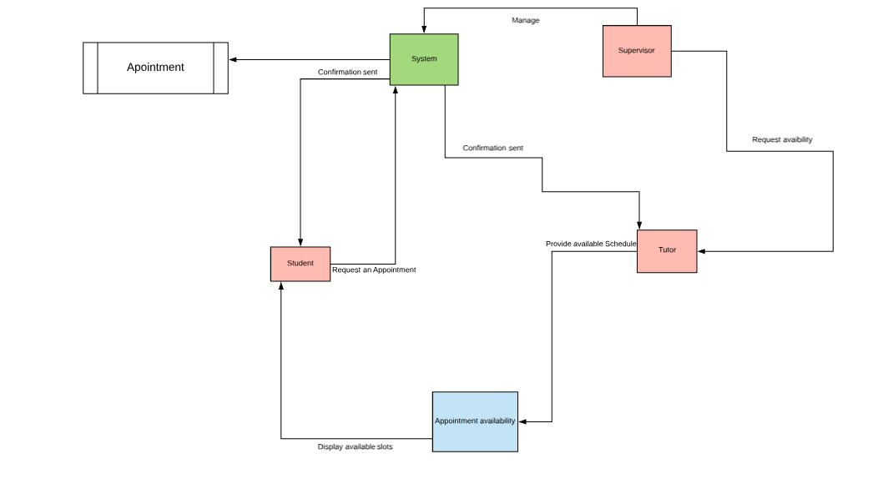

**Process:**

- **1st process =** We are working on“Appointment” in order to make a easy and flexible appointment system. The system carries everything inside of it.

- **2nd process =** “Appointment availability”: is where students can check for next available appointments and the requested appointment reports are sent to the system process.

- **3rd process =** “Students”: will be able to check the appointment availability and book a new appointment as needed.

- **4th process =** “Tutor”: will be able to provide their own schedule as availability for tutoring and will receive the confirmation every time when appointed.

- **5th process =** “Supervisor”: will manage and handle the entire system.

**Entity:**

- **1st Entity =** “Supervisor”: Is the person who will manage the overall system and changes in the appointment.

- **2nd Entity =** “Tutor”: Is the person who will provide their schedule for the appointment and help student.

- **3rd Entity =** “Students”: They are the customers who will book an appointment with the tutors as needed.

**Data Store:**

- **Datastore1 =** “Appointment” stores and generates all the requested and appointed appointments by the students and tutors.

**Data Flow:**

**- 1st Data Flow:** 1st data flow going into “Tutor” from “Supervisor” is for supervisor to request the availability of all the tutors to set up an appointment schedule.

- **2nd Data Flow:** 2nd data flow going into “Appointment availability” from “Tutor” this is when tutors provide their available hours to set up an appointment schedule.

- **3rd Data Flow:** 3rd data flow is going from “Appointment availability” to the “”System” here the report of tutors availability is sent to the system set up an appointment schedule for students.

- **4th Data Flow**: 4th data flow is going into “Students” from “Appointment availability” this is when the students will be displayed the available schedule.

- **5th Data Flow:** 5th data flow is going into “System” from the “Student” this is when student request or select their appointment with the tutors as needed or as available.

- **6th Data Flow:** 6th data flow is going into “Tutor” from “System” this is when the System sends a notification/confirmation to the tutor via text/email for the tutoring appointment.

- **7th Data Flow:** 7th data flow is going into “Students” from “System” this is when the System approves the students request for the appointment and sends the confirmation via text/email.

- **8th Data Flow:** 8th data flow is going into “Appointment” data store from the “System” when all the process are finished and finally the appointment is created and updated.

- **9th Data Flow:** 9th data flow is going into “System” from “Supervisor” this is when any changes are made after the “Appointment” is already created, where the Supervisor will handle and manage the changes.

Context DFD - Reports (Case Study 5)

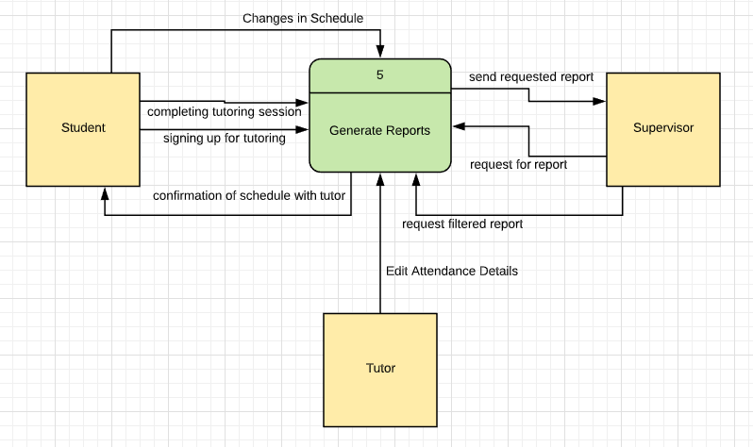

Level 0 DFD - Reports (Case Study 5)

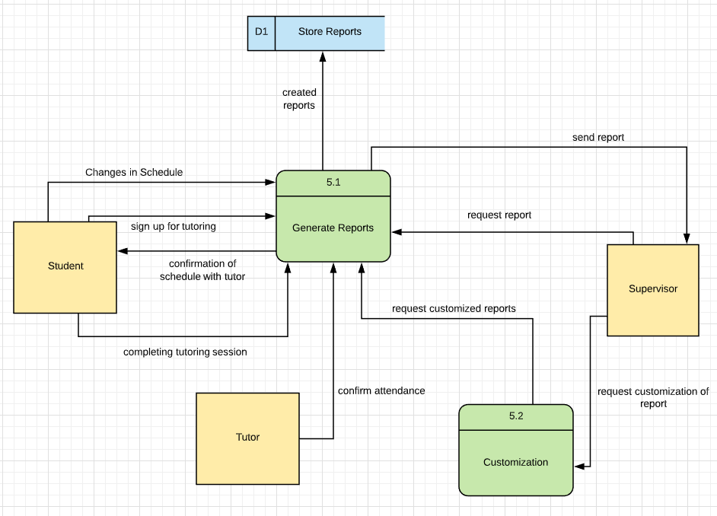

Text Definitions:

Context DFD: Reports

**Process**:

**Reports**: It creates reports for all tutoring sessions that are created, completed, and canceled.

**Entity**:

* **1st Entity** =“Students”: They are the customer that goes to the tutors when needing help in a certain subject or area.
* **2nd Entity** = “Supervisor”: Is the person that will oversee the whole business of what is going on between the student and tutors.
* **3rd Entity** = “Tutor” : is the person that will be conducting the tutoring session as well as make updates to reports.

**Data Flow:**

* **1st data flow:** going into Generate Reports(process) from the student is = “signing up for tutoring.” This is where it starts to create the report for any tutoring session that is requested.
* **2nd data flow:** going into the Generate Reports(process) from the student is = “ completing tutoring session.” This step is used to complete the reports in all the tutoring sessions that have occurred. Essentially, this is based on whether or not the session had taken place and if it was completed.
* **3rd data flow**: going into the Generate Reports(process) from the student is = “changes in schedule.” This step is to record any changes the students make after signing up for the tutoring session.
* **4th data flow**: going into the Student entity from the Generate Reports(process) is =”confirmation of schedule with tutor.” This step acts as a trigger based on the schedule that was generated from the student and tutor. It will ask for a confirmation from the student so the report can be held accountable in its acts of solidifying the tutoring session.
* **5th data flow**: going into the Generate Reports (process) from the supervisor is = “request for report.” This is an action that is taken place by the supervisor so that they can see an outline of the report that is generated for any particular tutoring session.
* **6th data flow:** going into the Generate Reports (process) from the supervisor is = “request filtered report.” This action is only used if the supervisor wanted to filter specific criteria in some or all reports such as, those who have not completed their tutoring session. These reports will have include the reports of those who have not completed their tutoring session.
* **7th data flow:** going into the supervisor entity from the Generate Reports(process) is = “send requested report.” This action is sent to the supervisor based on the action the supervisor had taken in viewing reports.
* **8th data flow:** going into the Generate Reports from the tutor entity is = “edit attendance details.” The tutor will be able to mark up the student if the student did or did not attend the tutoring session.

Level 0 DFD : Reports

**Process**:

**Reports**: It creates reports for all tutoring sessions that are created, completed, and canceled.

**Customization:** This process goes a bit further in the process of creating reports. This process allows the supervisors to create specific reports according to their own criteria.

**Entity**:

* **1st Entity** =“Students”: They are the customer that goes to the tutors when needing help in a certain subject or area.
* **2nd Entity** = “Supervisor”: Is the person that will oversee the whole business of what is going on between the student and tutors.
* **3rd Entity** = “Tutor” : is the person that will be conducting the tutoring session as well as make updates to reports.

**Data Store:**

* **1st Entity** = “Store Report”: This data store is used to keep and retain all reports that are generated by the app.

**Data Flow:**

* **1st data flow:** going into Generate Reports(process) from the student is = “signing up for tutoring.” This is where it starts to create the report for any tutoring session that is requested.
* **2nd data flow:** going into the Generate Reports(process) from the student is = “ completing tutoring session.” This step is used to complete the reports in all the tutoring sessions that have occurred. Essentially, this is based on whether or not the session had taken place and if it was completed.
* **3rd data flow**: going into the Generate Reports(process) from the student is = “changes in schedule.” This step is to record any changes the students make after signing up for the tutoring session.
* **4th data flow**: going into the Student entity from the Generate Reports(process) is =”confirmation of schedule with tutor.” This step acts as a trigger based on the schedule that was generated from the student and tutor. It will ask for a confirmation from the student so the report can be held accountable in its acts of solidifying the tutoring session.
* **5th data flow**: going into the Generate Reports (process) from the supervisor is = “request for report.” This is an action that is taken place by the supervisor so that they can see an outline of the report that is generated for any particular tutoring session.
* **6th data flow:** going into the Customization (process) from the supervisor is = “request customization of report.” This action is only used if the supervisor wanted to filter specific criteria in some or all reports such as, those who have not completed their tutoring session.
* **7th data flow:** going into the supervisor entity from the Generate Reports(process) is = “send report.” This action is sent to the supervisor based on the action the supervisor had taken in viewing reports. This is the standard report that is given to the supervisor based on one session.
* **8th data flow:** going into the Generate Reports(process) from the Customization(process) is = “request customized reports.” This causes the generate report process to actually carry out the filters and specific criteria the supervisor requested.
* **9th data flow:** going into the store reports(data store) from the Generate Reports(process) is = “created reports.” This data store will store all of the reports that are generated from the Generate Reports process.
* **10th data flow:** going into the Generate Reports from the tutor entity is = “edit attendance details.” The tutor will be able to mark up the student if the student did or did not attend the tutoring session.